Topic: Wildlife Conservation
Student Version

Summary:

You will understand more about the giant panda conservation work in our country and the importance of biodiversity conservation through the following activities.

- Viewing the video “Preserving Pandas” about conservation of giant pandas to understand more about our country’s efforts in protecting the endangered wildlife

- Reading the article “Panda’s Rise Shows Biodiversity Improving” to find out more about the development of giant panda preservation and understand the text structure and language items related to an article and a timeline

- Giving a presentation about endangered/vulnerable animals in China and the conservation work in our country

- Creating a digital story about an endangered animal in China and designing an itinerary for a volunteer programme to support the conservation of vulnerable species of our country

Part 1 – Pre-viewing
- Introduction
Ecological security, including water, land, atmosphere and biological species security, is the basic condition for human survival and development. Ecological damage, environmental pollution and epidemics have been posing threats to national ecological security. The conservation work of giant pandas has made significant contributions to the conservation of endangered wildlife and safeguarding national ecological security. Find out more about the giant pandas and the conservation work in our country that helps them thrive.

- Discussion
- How much do you know about giant pandas? Write down your thoughts in Boxes (a) – (d).
(b) Diet
What do giant pandas eat?

- Habitat
Where can we find giant pandas?

(c) Behaviour
What skills do giant pandas possess?

(d) Conservation
What are the potential threats to giant pandas’ natural habitat?

- Pandas were sent to other countries as gifts in the 1950s – 1980s. What do pandas symbolise in Chinese culture?

Part 2 – Video Viewing

- Watch the video “Preserving Pandas” and complete the flowchart below.
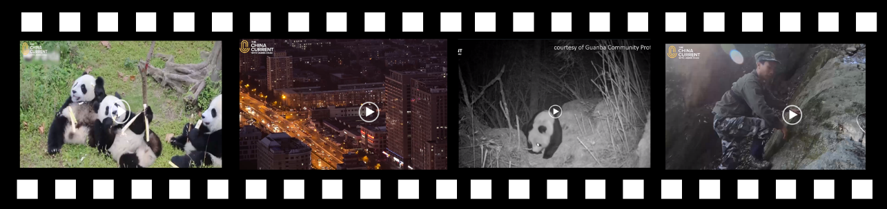
https://chinacurrent.com/education/article/2021/4/22977.html
Problem

Threats to Giant Pandas
- Human (a) _____________ and (b) _____________ to pandas’ natural habitat (c) _____________ of wild pandas in the 70s and 80s

Solution

Giant panda conservation efforts by (d) ____________ and (e) _____________
Better (g) _____________ foundation on conservation of giant pandas
China’s stricter (f) _____________ on giant pandas

Efforts and achievements of the Chinese government
in preserving giant pandas

The Guanba Community Protected Area, also known as the “World’s No.1 County for Pandas” or the (j) _____________ , has the (k) _____________ concentration of giant pandas in the whole world.
Giant panda habitats can be found in the following provinces in China:
- Gansu
- (h) _____________
- (i) _____________

- What do forest rangers do to support the conservation of giant pandas?

- Which of the following are the challenges faced by the forest rangers? Tick the appropirate boxes. (You can choose more than one.)
Sleeping in shelters with makeshift beds | Difficulty in finding a base camp
Not having enough food | Getting ready and setting off for  work very early in the morning
Hiking along dangerous paths | Risks of being attacked by wild animals

- What do you think about the job of being a forest ranger? Why do you think the forest rangers in China persist in their job despite the challenges?

- What can students do to support the conservation work of giant pandas in our country?

Part 3 – Post-viewing
- Reading

- You are going to read an article about the conversation of giant pandas.

- By studying the title of the article “Panda’s Rise Shows Biodiversity Improving”, predict the writer’s view on the present status of giant pandas.

The writer is _______________ about the conservation work of giant pandas.
- (A) angry
- (B) disappointed
- (C) positive
- (D) unsure

- Explain your answer.

- Study the word “Biodiversity”.

Bio- divers(e) -ity
Prefix

- Words related to “Bio-”:
_____________________

- Meaning:

_____________________

_____________________

Root

- Words related to “diverse”:

_____________________

- Meaning:

_____________________

______________________

Suffix

- Part of speech:

____________________

- Meaning:

____________________

____________________

- What does the word “Biodiversity” refer to?

- Read the article and answer the questions.

Panda’s Rise Shows Biodiversity Improving
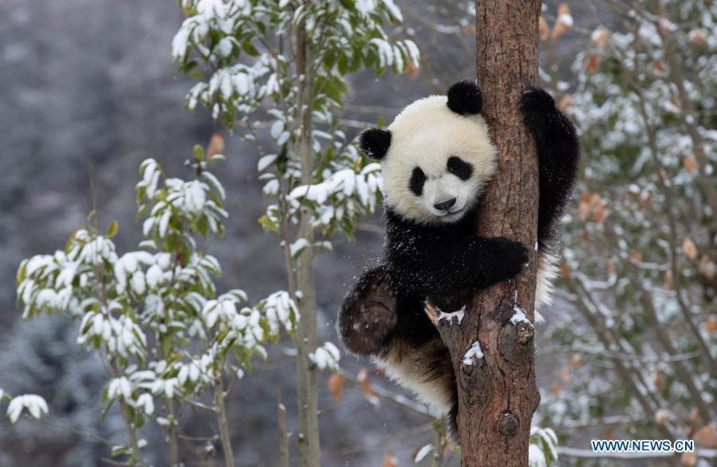
5  10  15  20  25  30  35  40 | A giant panda plays after snow at Shenshuping base of the China Conservation and Research Center for the Giant Panda in Wolong National Nature Reserve, Southwest China’s Sichuan province, December 17, 2020.  The removal of the giant panda from the list of endangered animals indicates that nature reserves are performing their duties in preserving the nation’s biodiversity, an official said.  “The panda population in the wild has risen to about 1,800, which reflects their improved living conditions and China’s efforts in keeping their habitats integrated,” Cui Shuhong, head of the Ministry of Ecology and Environment’s Department of Nature and Ecology Conservation, said at a news conference on Wednesday.  The fourth census on China’s panda population by the National Forestry and Grassland Administration found 1,864 pandas lived in the wild by 2013, up from 1,596 in 2003 when the third census was taken.  Since the 1970s, China has conducted four panda censuses, one every decade, which focused on Sichuan, Shaanxi and Gansu provinces, where the majority of pandas are located.  China’s protection methods have included setting up panda reserves, relocating residents from panda habitats, training local people to be rangers and breeding pandas in captivity.  In 2018, the Giant Panda National Park Administration based in Sichuan was established. The park, which connects fragmented habitats, also takes in parts of Shaanxi and Gansu and covers 87.5 percent of the country’s entire panda population, according to the park’s website.  A staff member from the China Conservation and Research Center for the Giant Panda in Wenchuan county, Sichuan, said, in the 2000s China solved three main problems of panda breeding: the difficulty for pandas to enter a mating cycle, impregnation and the low survival rate of cubs.  “Since 2006, we have managed to breed an increasing number of pandas in captivity, and about nine of them survived after being released into the wild,” he said.  “Despite that, the giant panda still remains under the State-level protection plan,” said the staff member, who only gave the name Zhang.  Wang Wenbin, a spokesman for the Foreign Ministry, said at a news conference on Thursday: “It is good to see more rare species active in China, such as Siberian tigers in the northeast, and the recent migration of Asian elephants to the north. Nowadays in China, there is a code of conduct among the government and people to respect and protect nature.”  In 2016, the International Union for Conservation of Nature announced that the giant panda’s status had been changed from “endangered” to “vulnerable” on the Red List of Threatened Species.  However, Chinese wildlife authorities remained cautious about the change at that time, saying it was still too early to remove giant pandas from the list of endangered animals based on the actual situation in China.
Source: https://www.chinadaily.com.cn/a/202107/09/WS60e78417a310efa1bd660ab5.html

(h) _______________________ (i) _______________________
The giant panda’s status on the Red List of Threatened Species (2016):
1,596 pandas (d) ________ in the wild.
(c) 2003
4. What is the role of the China Conservation and Research Center for the Giant Panda in Wolong National Nature Reserve?
__________________________________________________________________________
(f) 2006
Since 2006, (e) __________________
_______________________________. About nine of them survived after being released into the wild.
5. Complete the timeline below using information from the text.
1970s006
Since the (a) ________, China (b) ______________ four panda censuses, one every decade.
(g) __________________________.
2013
- Decide if the information in the following statements is “True”, “False” or “Not Given”.

What were the challenges in panda breeding? | Please tick () the appropriate box.
 | True | False | Not Given
- It was not easy to get pandas into the mating cycle.
- The female pandas had difficulty in getting pregnant.
- The pandas had difficulty in finding their partners.
- The panda cubs had a high survival rate.

- Find a word in lines 24-29 which means “keeping an animal in a designated place”.

- What is the Chinese wildlife authorities’ view on the decision to remove the giant pandas from the Red List of Threatened Species in 2016?

- (A) Careful
- (B) Ironic
- (C) Neutral
- (D) Supportive

- Why is biodiversity conservation important for safeguarding ecological security?

- What are the effective ways to raise students’ awareness of biodiversity conservation?

- Language Focus: Simple Past and Present Perfect

- Study the following sentences from the video “Preserving Pandas” and the article “Panda’s Rise Shows Biodiversity Improving”.

- In the following sentences, underline the verbs in the simple past tense and circle the verbs in the present perfect tense.
Once, the panda’s natural habitat covered a range extending just south of present-day Beijing all the way into Myanmar and Vietnam. But, human population growth has reduced and split up habitats.
Poaching in the 70s and 80s actually killed off many of the wild pandas here.

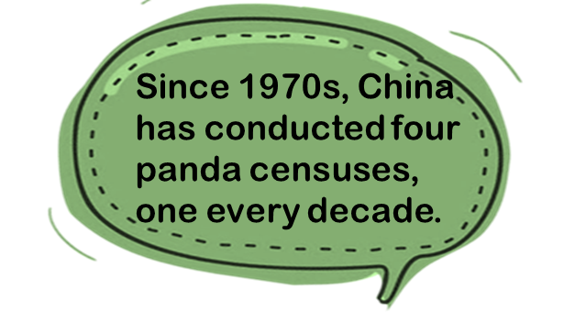
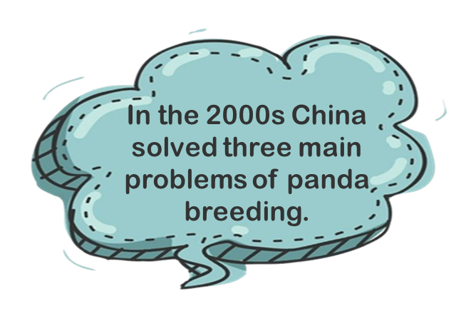
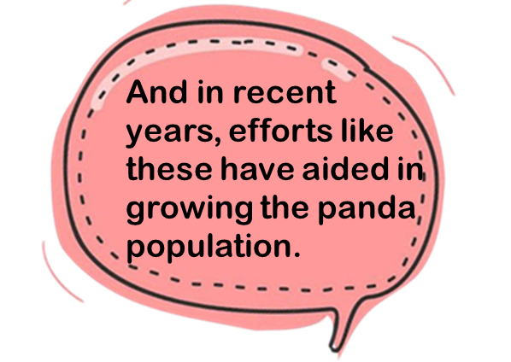
- Write the verbs in the table below.

Simple Past | Present Perfect

- Discuss with your classmates the difference between the use of the simple past and the present perfect to talk about the past.

Part 4 – Speaking
- The Chinese government has implemented multiple measures to protect the country’s most vulnerable wildlife through habitat protection, scientific research and captive breeding. Giant pandas, Asian elephants, Hainan gibbons, Siberian tigers, Chinese pangolins, crested ibises, Tibetan antelopes and milu deer are examples of key species under conservation.
As the Chairperson of the school’s Conservation Club, you are going to give a 3-minute presentation about endangered/vulnerable animals in China and the conservation work in our country at the school assembly.
Research information online about an endangered/a vulnerable animal in China. You may include the following in the presentation :
- Introduction of the animal
- Threats faced by the animal
- Conservation work done by the Chinese government
- Things we can do to support the conservation work of endangered species
Plan and organise your ideas by using the note sheet below:
- Introduction of the animal (e.g. habitat, diet, behaviour)

- Threats faced by the animal

- Name of the endangered/vulnerable species:

____________________________

Photo of the species

- Conservation work done by the Chinese government

- Things we can do to support the conservation work of endangered species

